Software Tool
# Source: AI Source: Provided by: [Data Path: Persons Table -> ID Column: 1, Name_En Column: Motasem Essam] -> From: [ChatGPT] on [1/23/2026]
A Software Tool is a program or application designed to help perform specific tasks, often to assist developers, users, or systems in completing work efficiently.
It’s usually not a full application for end-users, but something that helps with development, management, automation, or analysis.

Key Points
# Source: AI Source: Provided by: [Data Path: Persons Table -> ID Column: 1, Name_En Column: Motasem Essam] -> From: [ChatGPT] on [1/23/2026]
- Purpose – Makes a specific task easier or automates it.
- Functionality – Usually specialized, e.g., building software, analyzing data, managing packages.
- Users – Often targeted at developers, IT professionals, or power users.

Examples
# Source: AI Source: Provided by: [Data Path: Persons Table -> ID Column: 1, Name_En Column: Motasem Essam] -> From: [ChatGPT] on [1/23/2026]
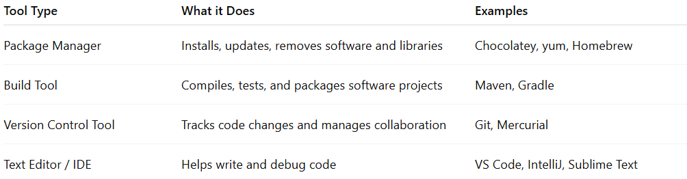

Tool Type | What it Does | Examples
Package Manager | Installs, updates, removes software and libraries | Chocolatey, yum, Homebrew
Build Tool | Compiles, tests, and packages software projects | Maven, Gradle
Version Control Tool | Tracks code changes and manages collaboration | Git, Mercurial
Text Editor / IDE | Helps write and debug code | VS Code, IntelliJ, Sublime Text

Overlapping Roles of Software Tools
# Source: AI Source: Provided by: [Data Path: Persons Table -> ID Column: 1, Name_En Column: Motasem Essam] -> From: [ChatGPT] on [1/23/2026]
In modern software development, many tools don’t fit neatly into a single category. Some tools perform multiple roles, such as managing software packages, handling project dependencies, and automating builds.
Understanding these overlaps helps you:
- Choose the right tool for the task – system installation, project dependencies, or build automation.
- Avoid confusion – some tools (like npm or pip) can act as both package managers and dependency managers, and sometimes even as build tools.
- Design better workflows – knowing which role each tool plays helps you structure projects, manage dependencies, and automate builds efficiently.
Below is a categorized list showing which tools act in single roles and which can overlap multiple roles.

Ah, yes — the confusion with npm is similar to what we saw with pip. Let me clarify and rewrite the categories carefully so there’s no overlap with “only”.

1️⃣ Package Manager Only
# Source: AI Source: Provided by: [Data Path: Persons Table -> ID Column: 1, Name_En Column: Motasem Essam] -> From: [ChatGPT] on [1/23/2026]
- Definition: Installs and manages software packages globally on the system; does not manage project dependencies or run builds.
- Examples:
  - apt (Linux)
  - yum (Red Hat/Fedora)
  - Homebrew (macOS)
  - Chocolatey (Windows)

2️⃣ Build Tool Only
# Source: AI Source: Provided by: [Data Path: Persons Table -> ID Column: 1, Name_En Column: Motasem Essam] -> From: [ChatGPT] on [1/23/2026]
- Definition: Automates compiling, testing, and packaging projects; does not manage system packages or project dependencies.
- Examples:
  - Make (C/C++)
  - Ant (Java)

3️⃣ Dependency Manager Only
# Source: AI Source: Provided by: [Data Path: Persons Table -> ID Column: 1, Name_En Column: Motasem Essam] -> From: [ChatGPT] on [1/23/2026]
- Definition: Manages libraries/dependencies for a project; does not install system software or run build scripts.
- Examples:
  - Bundler (Ruby)
  - Composer (PHP)

4️⃣ Acts as Both Package Manager and Dependency Manager
# Source: AI Source: Provided by: [Data Path: Persons Table -> ID Column: 1, Name_En Column: Motasem Essam] -> From: [ChatGPT] on [1/23/2026]
- Definition: Installs software packages and manages project dependencies; does not handle building or compiling.
- Examples:
  - pip (Python, when installing global packages and project libraries)

5️⃣ Acts as Both Build Tool and Dependency Manager
# Source: AI Source: Provided by: [Data Path: Persons Table -> ID Column: 1, Name_En Column: Motasem Essam] -> From: [ChatGPT] on [1/23/2026]
- Definition: Builds projects and manages project dependencies; does not install system software globally.
- Examples:
  - Maven (Java)
  - Gradle (Java/Kotlin)
  - sbt (Scala)

6️⃣ Acts as Package Manager, Dependency Manager, and Build Tool
# Source: AI Source: Provided by: [Data Path: Persons Table -> ID Column: 1, Name_En Column: Motasem Essam] -> From: [ChatGPT] on [1/23/2026]
- Definition: Can install software, manage project dependencies, and run build/test scripts.
- Examples:
  - npm (Node.js, with global packages + project dependencies + scripts)
  - yarn (Node.js, project dependencies + scripts)

✅ Important Note:
- “Only” means the tool strictly performs that one role.
- npm and pip can appear in multiple categories depending on how you use them:
  - npm global install → Package Manager role
  - npm install for project → Dependency Manager role
  - npm run scripts → Build Tool role

✅ Summary
# Source: AI Source: Provided by: [Data Path: Persons Table -> ID Column: 1, Name_En Column: Motasem Essam] -> From: [ChatGPT] on [1/23/2026]
- Software Tool = a program that helps you do something specific efficiently.
- Can be part of development, system maintenance, or productivity.
- Examples include package managers, build tools, and IDEs.

